**Batch: B1 Roll No.: 16010121045**

**Experiment No. 7**

|  |
| --- |
| **Title:**  Implementation and configuration of Firewall |

**Objective:** Implementation and configuration of Firewall

|  |  |
| --- | --- |
| **CO** | **Outcome** |
| **CO3** | Illustrate Secure software design principles and apply them for secure software development |

**Books/ Journals/ Websites referred:**

[**https://www.javatpoint.com/types-of-firewall**](https://www.javatpoint.com/types-of-firewall)

[**https://www.techtarget.com/searchsecurity/feature/The-five-different-types-of-firewalls**](https://www.techtarget.com/searchsecurity/feature/The-five-different-types-of-firewalls)

**Abstract**:-

Firewalls serve as essential components of network security, acting as barriers between a trusted internal network and untrusted external networks, typically the internet. Implementing and configuring firewalls using tools like iptables, Fortinet, or Palo Alto Networks involves several key principles and practices to ensure effective protection.

Iptables, a command-line utility for configuring the Linux kernel firewall, provides granular control over network traffic. Its implementation involves defining rulesets specifying allowed or denied traffic based on criteria such as source/destination IP addresses, ports, and protocols. By configuring iptables, administrators can establish policies to permit legitimate traffic while blocking malicious or unauthorized access attempts.

Fortinet and Palo Alto Networks offer comprehensive firewall solutions with advanced features for threat detection, intrusion prevention, and application control. Implementation of these firewalls typically involves deploying dedicated hardware appliances or virtual instances within the network infrastructure. Configuration entails defining security policies tailored to the organization's requirements, considering factors like permitted applications, user access privileges, and threat intelligence feeds.

In both iptables and enterprise-grade firewall solutions like Fortinet and Palo Alto Networks, effective configuration relies on understanding network topology and security requirements. Administrators must carefully design rule sets to balance security and functionality, avoiding overly permissive policies that may expose the network to risks or overly restrictive policies that hinder legitimate business activities.

Furthermore, ongoing monitoring and maintenance are crucial aspects of firewall management. Regular review of firewall logs, updating rule sets to address emerging threats, and conducting periodic security assessments help ensure continued effectiveness.

In summary, implementing and configuring firewalls using iptables, Fortinet, or Palo Alto Networks involves defining and enforcing security policies tailored to the organization's needs. Whether through open-source tools like iptables or enterprise-grade solutions, a proactive approach to firewall management is essential for safeguarding network assets and maintaining a strong security posture.

**Related Theory: -**

1. **Packet Filtering Firewalls**:
   * **Cryptographic Applications**: Packet filtering firewalls don't typically directly involve cryptography. However, they can be used in conjunction with cryptographic protocols like IPsec for secure communication between networks.
   * **Strengths**:
     + Simple and efficient for filtering traffic based on predefined rules.
     + Low overhead on network performance.
   * **Weaknesses**:
     + Vulnerable to IP spoofing attacks.
     + Limited ability to inspect traffic beyond the network layer, making it difficult to detect certain types of attacks like application-layer attacks.
2. **Stateful Inspection Firewalls**:
   * **Cryptographic Applications**: Stateful inspection firewalls can be used in conjunction with cryptographic protocols like SSL/TLS to inspect encrypted traffic.
   * **Strengths**:
     + Provides enhanced security by maintaining context about the state of active connections.
     + Can inspect traffic up to the application layer, allowing for better detection of suspicious activities.
   * **Weaknesses**:
     + More resource-intensive compared to packet filtering firewalls.
     + Vulnerable to certain types of attacks like state-exhaustion attacks.
3. **Proxy Firewalls**:
   * **Cryptographic Applications**: Proxy firewalls can decrypt and inspect encrypted traffic, so they are often used with cryptographic protocols like SSL/TLS for secure communication.
   * **Strengths**:
     + Provides a high level of security by acting as an intermediary between internal and external networks.
     + Can provide content caching and logging capabilities.
   * **Weaknesses**:
     + May introduce additional latency due to the extra processing required for each connection.
     + More complex to configure and maintain compared to other types of firewalls.
4. **Next-Generation Firewalls (NGFW)**:
   * **Cryptographic Applications**: NGFWs can utilize cryptographic techniques like SSL/TLS decryption and inspection to analyze encrypted traffic.
   * **Strengths**:
     + Combines traditional firewall functionality with advanced features such as intrusion prevention, application awareness, and deep packet inspection.
     + Provides granular control over network traffic based on application, user, and content.
   * **Weaknesses**:
     + Can be complex to configure and may require specialized knowledge to effectively utilize advanced features.
     + Higher cost compared to traditional firewalls.

Each type of firewall has its own cryptographic applications, strengths, and weaknesses, and the choice of firewall depends on factors such as the specific security requirements, network architecture, and budget constraints.

**Implementation:**

For macOS, the firewall configuration and management are primarily handled through the built-in "pf" (Packet Filter) firewall and the graphical interface provided by the Security & Privacy settings. Let's break down the steps for each of the tasks you mentioned:

(a) Configuration of the static IP and general settings of the firewall:

1. Setting a static IP: This can be done through System Preferences > Network > Select the network interface > Configure IPv4 > Manually. Here, you can specify the IP address, subnet mask, router (gateway), and DNS servers.
2. General settings of the firewall: Go to System Preferences > Security & Privacy > Firewall. Here, you can turn the firewall on or off and customize its settings. You can choose to block all incoming connections, enable stealth mode, and specify which applications are allowed to accept incoming connections.

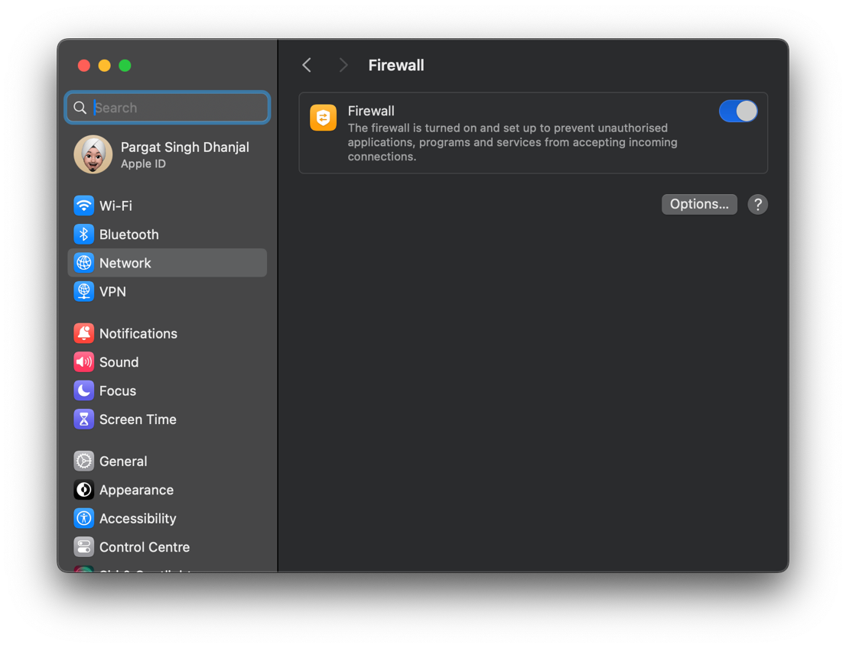

(b) Configuration of DHCP server, zones, and connection of clients to the internet: macOS doesn't have a built-in DHCP server, so you would need to use third-party software for this purpose. However, macOS can easily connect to a DHCP server to obtain its IP address and other network settings.

(c) Configuration of source NAT (SNAT) & destination NAT (DNAT): macOS's built-in firewall, pf, supports NAT configurations. You would typically write rules in the pf configuration file (/etc/pf.conf) to configure NAT. Here's an example of configuring NAT with pf:

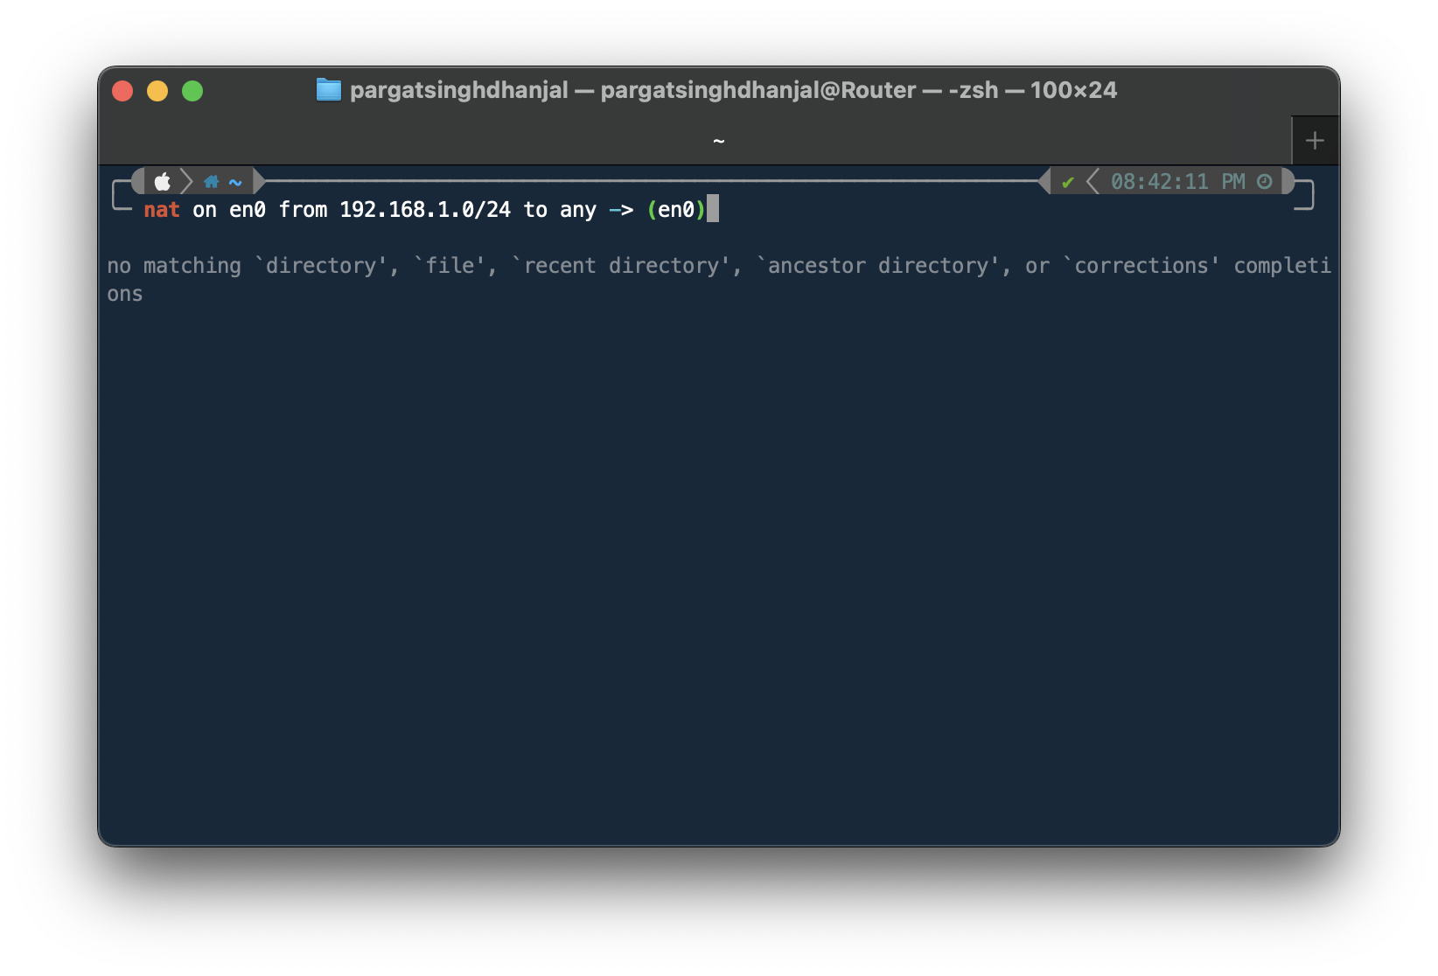

This rule performs source NAT for outgoing connections from the 192.168.1.0/24 subnet, using the IP address of the en0 interface.

(d) Configuration of basic security policies: You can configure basic security policies using the macOS firewall settings in System Preferences > Security & Privacy > Firewall. Here, you can create rules to allow or block incoming connections to specific applications or services.

(e) Blocking specific files, viruses: macOS includes built-in anti-malware protection called XProtect, which automatically scans downloaded files for known malware. Additionally, you can use third-party antivirus software for more comprehensive protection.

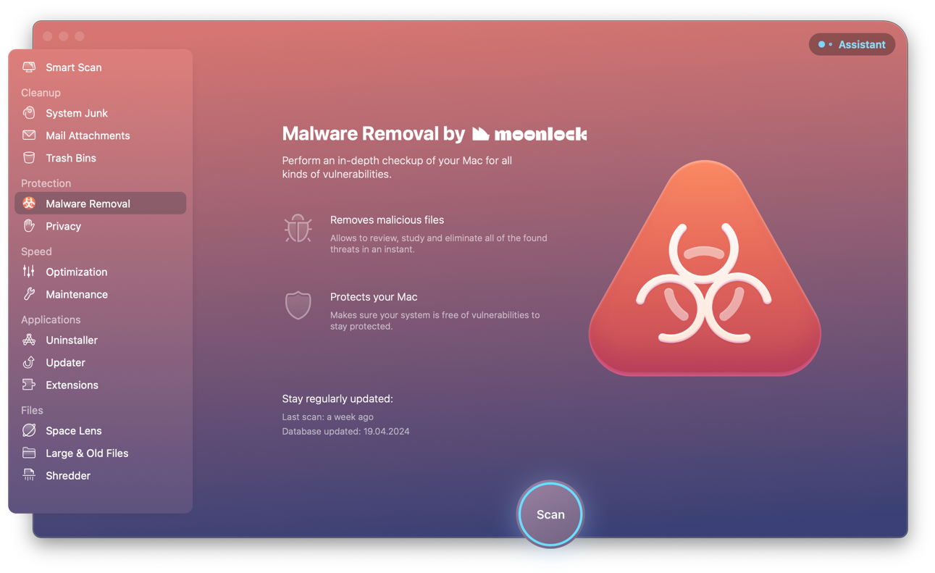

Above is a tool called CleanMyMac that automatically scans for downloaded files for malware.

**Conclusion:-** Hence, we understood and implemented email security using PGP.

**Postlab Questions:**

**7.1 Difference between stateful and stateless firewalls**:

* **Stateful Firewalls**: These firewalls keep track of the state of active connections. They maintain a state table that tracks the state of each connection, including information such as source and destination IP addresses, ports, and sequence numbers. Stateful firewalls can make more intelligent decisions about allowing or blocking traffic based on the context of the connection.
* **Stateless Firewalls**: Stateless firewalls, on the other hand, do not maintain any information about the state of connections. They operate based on predefined rules for filtering packets, typically examining each packet individually without considering the context of the connection. Stateless firewalls are simpler and have lower overhead but may be less effective at detecting and preventing certain types of attacks.

**7.2 How a firewall protects data**: A firewall protects data by acting as a barrier between a trusted internal network and untrusted external networks (such as the internet). It examines incoming and outgoing network traffic based on a set of predefined rules or policies and decides whether to allow or block that traffic. By enforcing these rules, a firewall can:

* Prevent unauthorized access to the network and its resources.
* Control the flow of data between different network segments or devices.
* Detect and block malicious activities, such as hacking attempts, malware infections, and unauthorized data transfers.
* Provide logging and reporting capabilities to monitor network traffic and security incidents.

In summary, a firewall protects data by controlling and monitoring network traffic according to security policies, thereby reducing the risk of unauthorized access and data breaches.

**7.3 What a firewall can't protect against**: While firewalls are essential components of network security, they have limitations and cannot protect against all types of threats. Some examples include:

* Insider threats: Firewalls cannot prevent authorized users from intentionally or accidentally misusing data or resources within the network.
* Social engineering attacks: Firewalls cannot prevent users from being tricked into disclosing sensitive information or performing actions that compromise security.
* Zero-day exploits: Firewalls may not be able to detect and block newly discovered vulnerabilities or attacks for which no signature or pattern exists.
* Encrypted traffic: Firewalls may have limited visibility into encrypted traffic, making it challenging to inspect and detect malicious activities within encrypted communications.
* Physical security breaches: Firewalls cannot prevent physical access to network infrastructure or devices, so additional physical security measures are necessary to protect against physical attacks or tampering.